U: root

pw: root

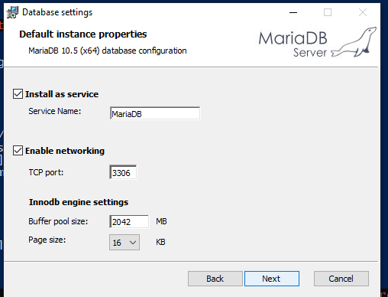

>mysql -u root -p -h localhost

Then use source createdb.slq

Use the installer to install mariadb server. For linux, there’s just a few simple commands.

The